WSEI University in Lublin

Faculty of Transportation and Information
Virtualization techniques, containerization
Laboratory
Mini-RAID with MinIO in Docker
Name: Winston Huruva
Student ID: 43614

Lublin 2025

Environment Setup
Install MinIO Client (mc):
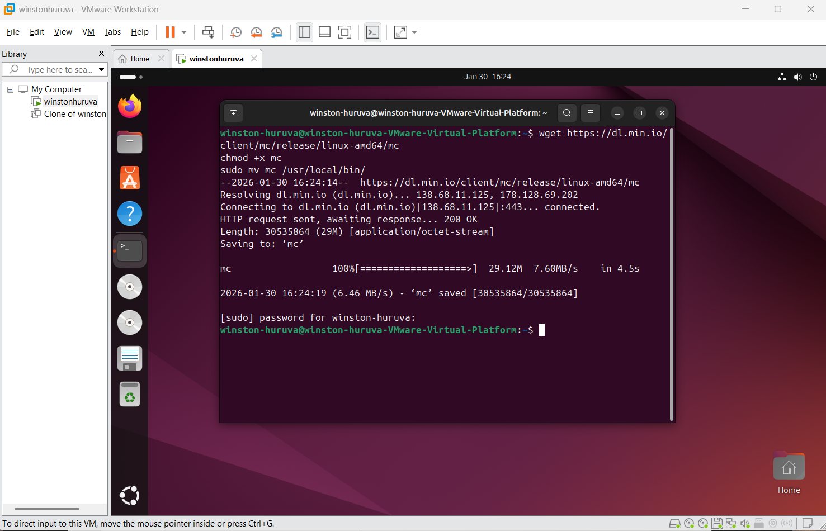

Create Docker Volumes
Create 4 volumes to act as mini-RAID in distributed mode:
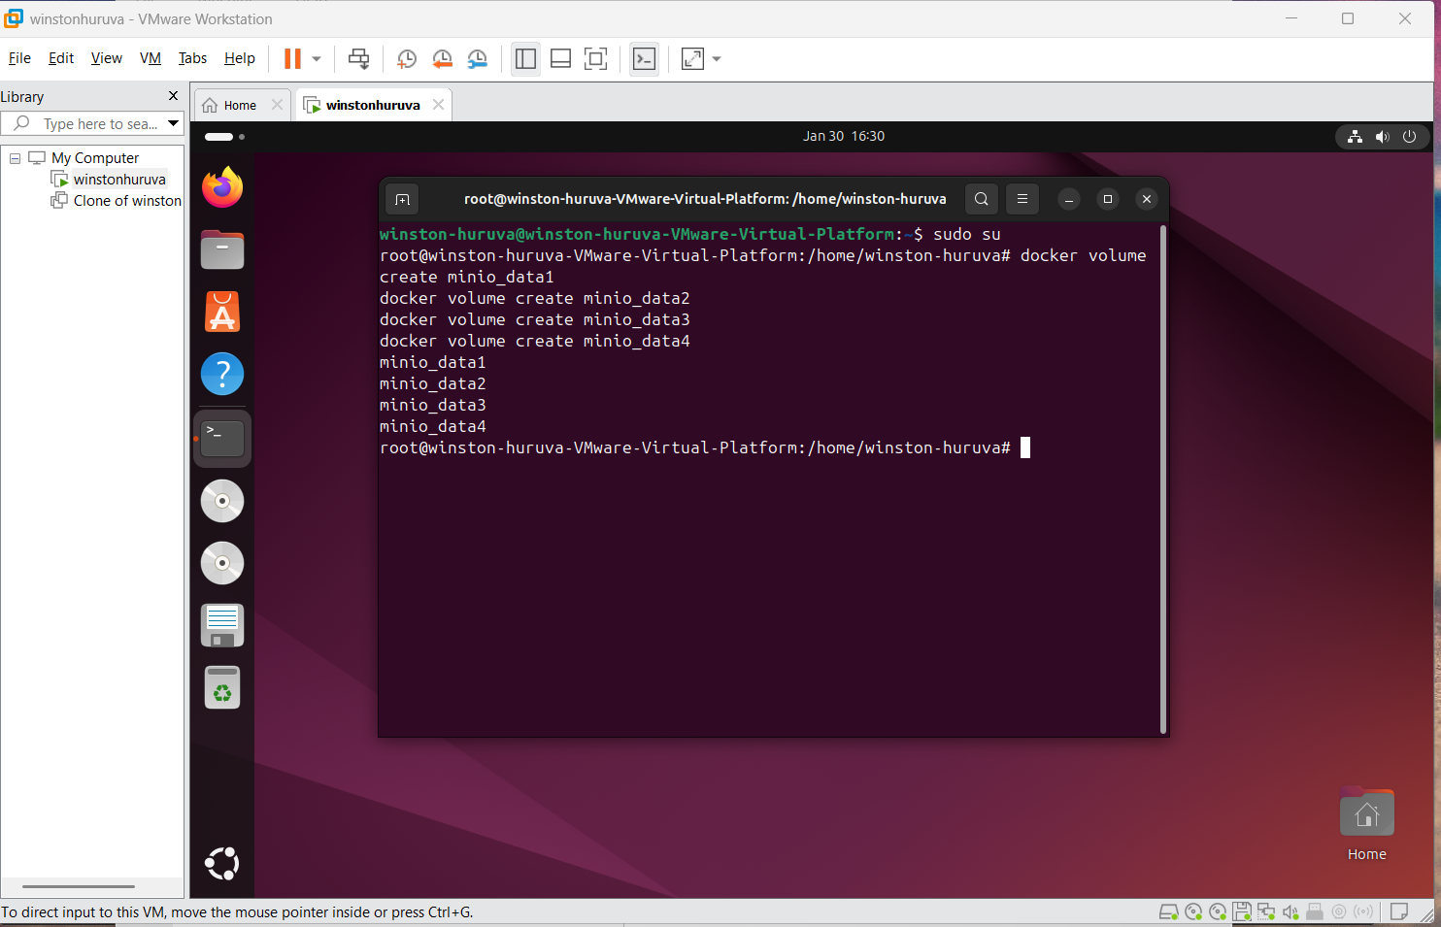
Check volumes:

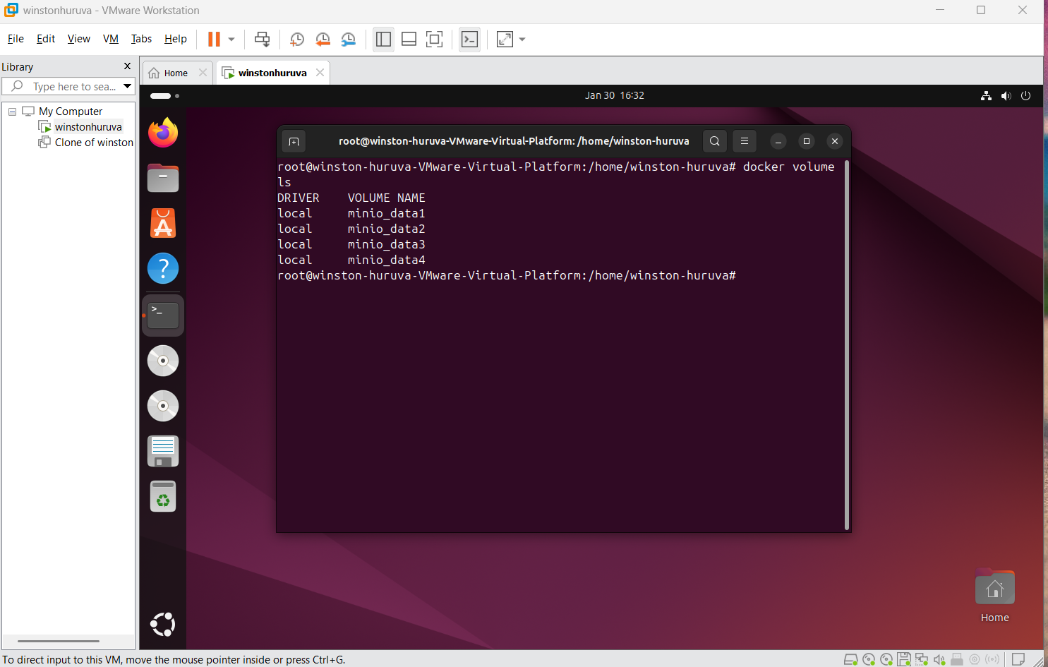

Run MinIO in Distributed Mode
MinIO requires at least 4 disks in distributed mode:

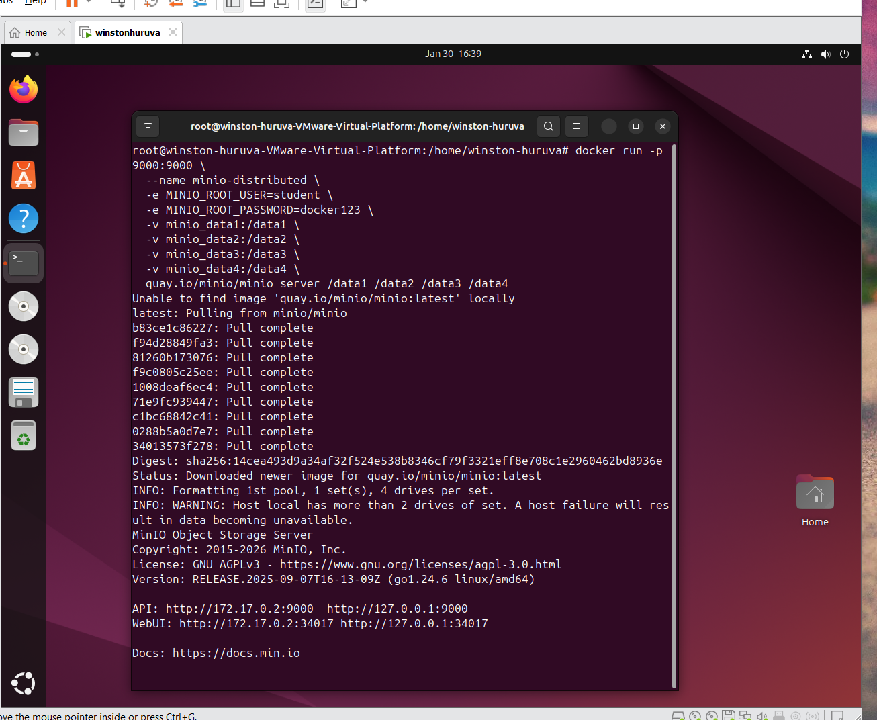

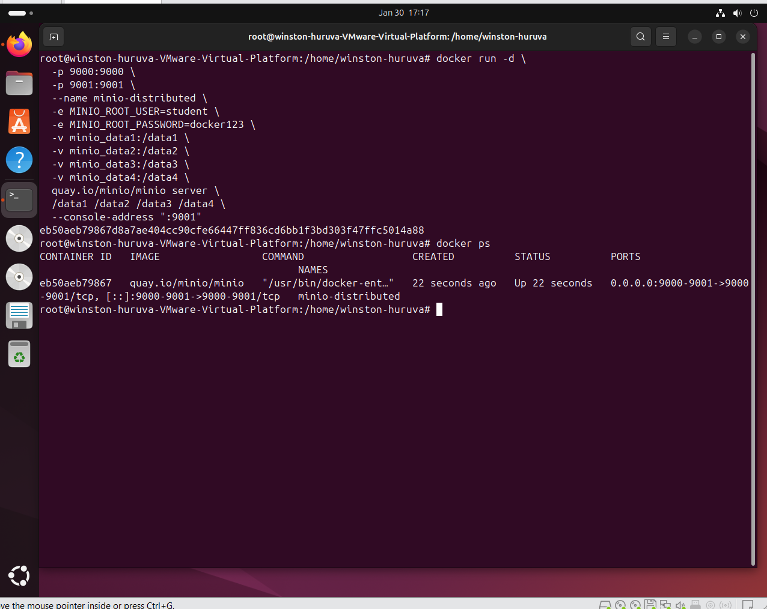

GUI Login and Check
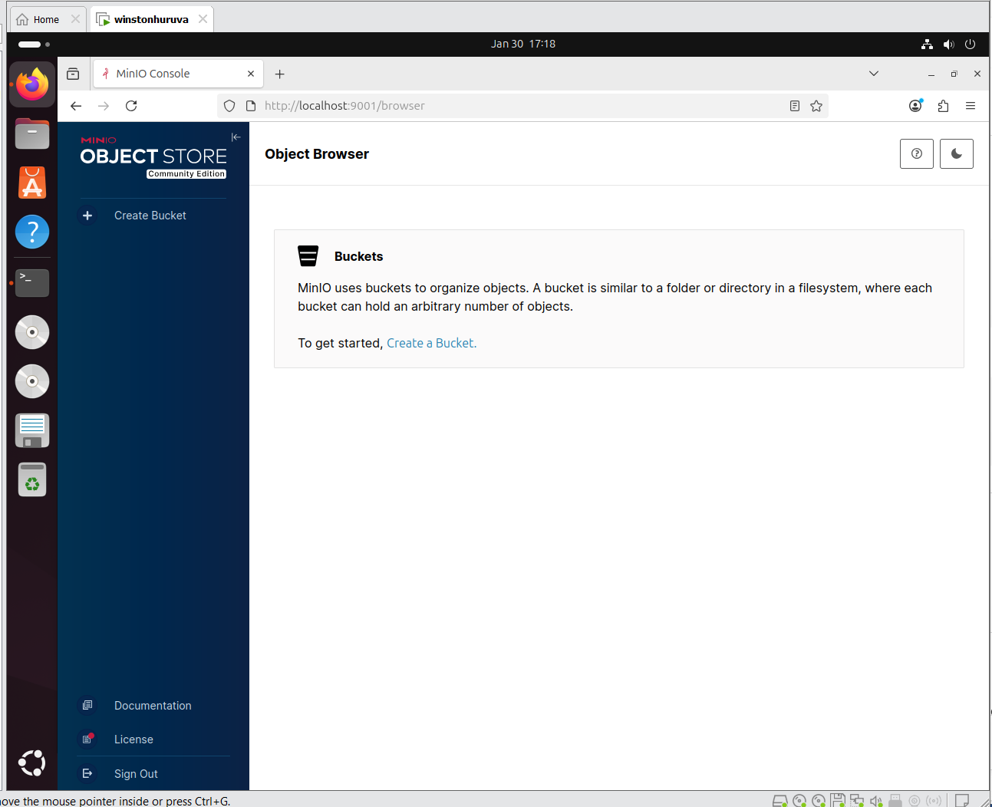

Add alias to local MinIO:
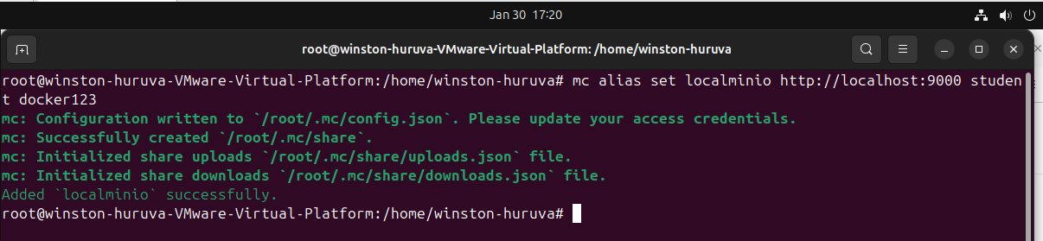

Test disks
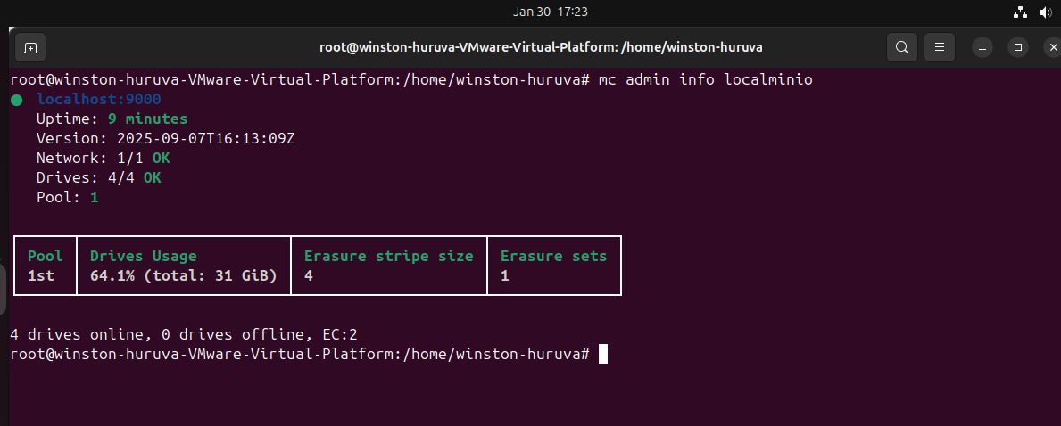
Create bucket:

Upload test file:
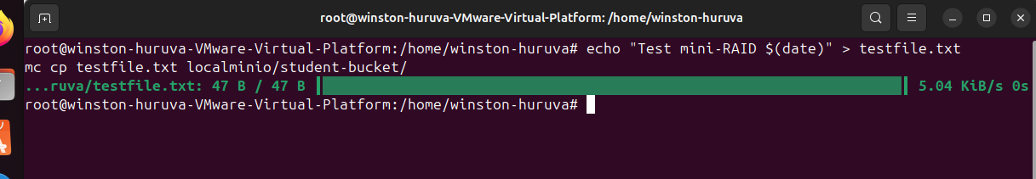
Download file

Check integrity (integrity preserved):
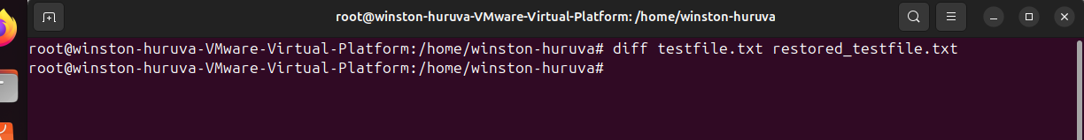

Resilience Test (Simulate Volume Failure)
